**Timeline Coverage Report**

1. **Background**
2. Language: C# .Net
3. UI Framework : WPF
4. IDE: Visual Studio
5. Coverage Testing Tool : Automatic in Visual Studio
6. **Coverage Report**

**(1) Unit Test Coverage Report**

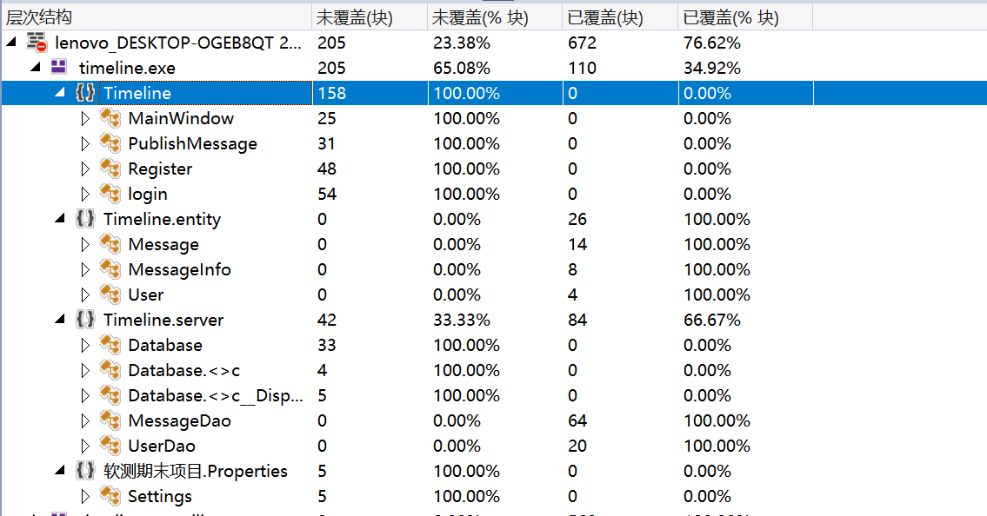

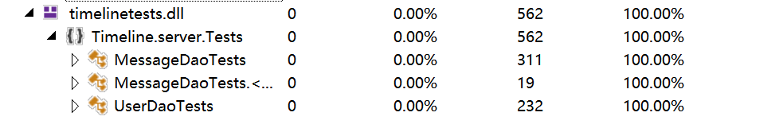

1. **Integration Test Coverage Report**

